Alpha1 AntiTrypsin Deficiency:

www.alpha1.org

ALS:

The ALS Association
www.alsa.org

ARDS:

Adult Respiratory Distress Syndrome
Clinical Network
www.ardsnet.org

ARDS Foundation
www.ardsusa.org

Asbestosis:

Asbestos Disease Awareness Organization
www.asbestosdiseaseawareness.org

Asthma:

Allergy and Asthma Network/Mothers of Asthmatics, Inc.
www.aanma.org

Asthma and Allergy Foundation of America
www.aafa.org

COPD/Emphysema:

COPD-Alert
www.copd-alert.com

COPD Foundation
www.copdfoundation.org

COPD International
www.copd-international.com

COPD Resources (Sponsored by GSK)
www.copd.com

COPD-Support
www.copd-support.com

EFFORTS (Emphysema Foundation for our right to Survive)
www.emphysema.net

Global Initiative for Chronic
Obstructive Lung Disease
www.goldcopd.com
Cystic Fibrosis:

CysticFibrosis.Com
www.cysticfibrosis.com

The Cystic Fibrosis Foundation
www.cff.org

Cystic Fibrosis Research Inc.
www.cfri.org

Disability

International Center for Disability Resources on the Internet
www.icdri.org/

Lung Cancer:

Lung Cancer Alliance
www.lungcanceralliance.org/

Lung Transplantation:

The Second Wind Lung Transplant
Organization, Inc.
www.2ndwind.org

Oxygen Therapy:

LTOT – Long Term Oxygen Therapy Network
www.ltotnetwork.org

Pulmonary Fibrosis:

Pulmonary Fibrosis Foundation
www.pulmonaryfibrosis.org

Pulmonary Hypertension:

Pulmonary Hypertension Association
www.phassociation.org

Sarcoidosis:

Foundation for Sarcoidosis Research
www.stopsarcoidosis.org

Worldwide Sarcoidosis Research Study
www.sarcoidstudy.org

Scleroderma:

International Scleroderma Network
www.sclero.org

Sleep Apnea:

American Sleep Apnea Organization
www.sleepapnea.org

National Sleep Foundation
www.sleepfoundation.org

Tobacco Cessation:

Center for Tobacco Research and Intervention
www.ctri.wisc.edu

Quitnet
quitnet.meyouhealth.com

Office of the Surgeon General,
Tobacco Cessation Guidelines
www.surgeongeneral.gov/priorities/tobacco

Tuberculosis:

CDC Tuberculosis Guidelines
www.cdc.gov/tb

Vasculitis (Wegener’s, Churg-Strauss):
www.vasculitisfoundation.org

Information Resources/ Professional Organizations:

American Academy of Allergy,
Asthma and Immunology
www.aaaai.org

American Academy of Sleep Medicine
www.aasmnet.org

American Association of Cardiovascular
and Pulmonary Rehabilitation
www.aacvpr.org

American Association of Respiratory Care
www.aarc.org

American Cancer Society
www.cancer.org

American College of Allergy,
Asthma and Immunology
www.acaai.org

American College of Chest Physicians
www.chestnet.org

American Heart Association
www.americanheart.org

American Lung Association
www.lung.org

American Thoracic Society
www.thoracic.org

Joint Council of Allergy, Asthma and Immunology
www.jcaai.readyportal.net/

Center for Disease Control
www.cdc.gov

Clinical Trials Resource - NIH
http://clinicaltrials.gov

Inspire – Support groups
www.inspire.com

Medscape
www.medscape.com

National Heart, Lung and Blood Institute
www.nhlbi.nih.gov

National Jewish Medical and Research Center
www.nationaljewish.org

National Lung Health Education Program
www.nlhep.org

National Organization for Rare Disorders (NORD)
www.rarediseases.org

Oncolink (cancer resources)
www.oncolink.upenn.edu

PubMed (Medline)
www.pubmed.gov

Pulmonary Education and Research Foundation
www.perf2ndwind.org

Understanding and reading your Pulmonary Function tests:
www.PFTPatient.com

WebMD
www.webmd.com
Your Lung Health
www.yourlunghealth.org

Internet Resources
For Pulmonary Patients

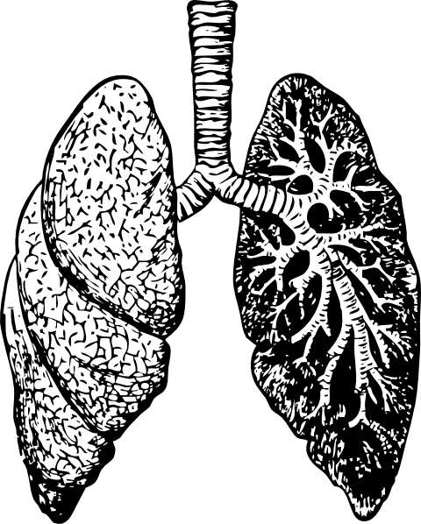

Last reviewed and updated:
11/15/2016

PFTForum.com

